**DAILY ONLINE ACTIVITIES SUMMARY**

|  |  |  |  |  |  |  |  |
| --- | --- | --- | --- | --- | --- | --- | --- |
| **Date:** | **21/07/2020** | | | | **Name:** | **Namratha C** | |
| **Sem & Sec** | **8th sem, A sec** | | | | **USN:** | **4AL16CS056** | |
| **Online Test Summary** | | | | | | | |
| **Subject** | | **NA** | | | | | |
| **Max. Marks** | |  | | **Score** | |  | |
| **Certification Course Summary** | | | | | | | |
| **Course** | **Introduction to Digital Marketing** | | | | | | |
| **Certificate Provider** | | | **Great Learning** | **Duration** | | | **2.5 hrs** |
| **Coding Challenges** | | | | | | | |
| **Problem Statement: Java Example to find the square root without sqrt() method**  **{**  **// Method 1: Using String object**  **char[] ch = {'g', 'o', 'o', 'd', ' ', 'm', 'o', 'r', 'n', 'i', 'n', 'g'};**  **String str = new String(ch);**  **System.out.println(str);**    **// Method 2: Using valueOf method**  **String str2 = String.valueOf(ch);**  **System.out.println(str2);**  **}**  **}** | | | | | | | |
| **Status: Completed** | | | | | | | |
| **Uploaded the report in Github** | | | | **Yes** | | | |
| **If yes Repository name** | | | | **CODES(Namrathasonu)** | | | |
| **Uploaded the report in slack** | | | | **Yes** | | | |

Online Test Details: No test conducted

Certification Course Details:

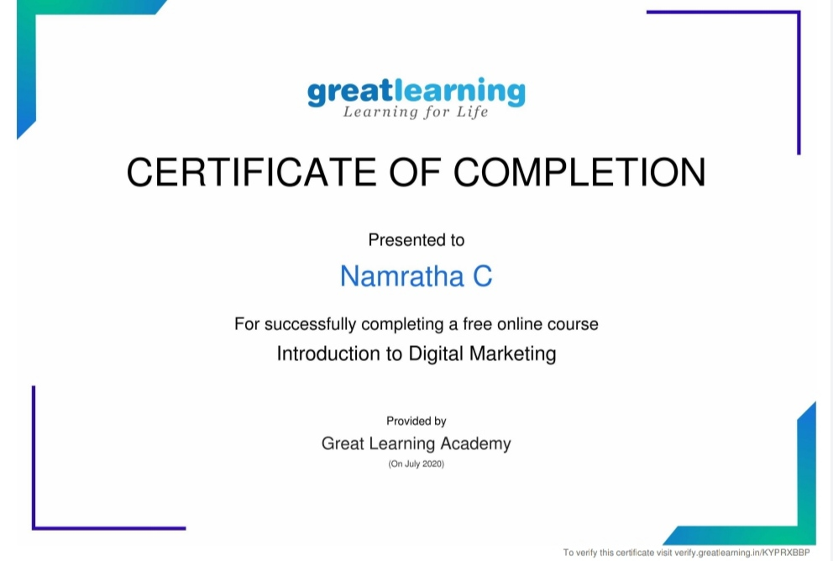

Coding Challenges Details:

package com.beginnersbook;

import java.util.Scanner;

class JavaExample {

public static double squareRoot(int number) {

double temp;

double sr = number / 2;

do {

temp = sr;

sr = (temp + (number / temp)) / 2;

} while ((temp - sr) != 0);

return sr;

}

public static void main(String[] args)

{

System.out.print("Enter any number:");

Scanner scanner = new Scanner(System.in);

int num = scanner.nextInt();

scanner.close();

System.out.println("Square root of "+ num+ " is: "+squareRoot(num));

}

}